Have tried the basics of mesh near home.

Going out from the home until the unit stop sending data.

Go back to where it received data again and leave the connecting node.

Walk away from the node into the known dead area and keep sending data.

Verified that it does work at the very least.

Some issues with hardware design and incorporation have shown up. Trying to make things a bit smaller and more space efficient has not worked as well as I had hoped. Finding some products from Sparkfun that seemed to be perfect for what I wanted to have not ended up working out. Due to the limitation on time, these have been tested and abandoned to maintain some semblance of staying on track.

Adding in a battery to external power has not quite worked as well as I had hoped. There were some issues with testing and have abandoned them for the moment to continue to make more forward progress with overall concept.

Using another Sparkfun product to help minimize space that does work half defeats the purpose of using the XBEE as a low voltage radio because the separate board requires 5v instead of 3.3v due to the LEDs on it (they say that it can go down to 3.3v but don’t think it worked right), and they’re just terrible LEDS. The Dev board for XBEE works better and has a 3.3v battery port for external power. Need to test powering that directly from the teensy or argon

The pin size/layout for the XBEE has been somewhat problematic. Noncompatible size all around for breadboard. The Dev board can have compatible pins but ends up being to wise to set on a single wide breadboard.

Trying to add on RP-SMA edge board connectors for the XBEE has been problematic. It seems like I got one board to sort of work with it, but overall, with the time frame it probably won’t be something I’ll be able to investigate further and get working properly. I would think it’s a simple solder and it would work set up, but need to do more research

Teensy 3.1 xbee adapter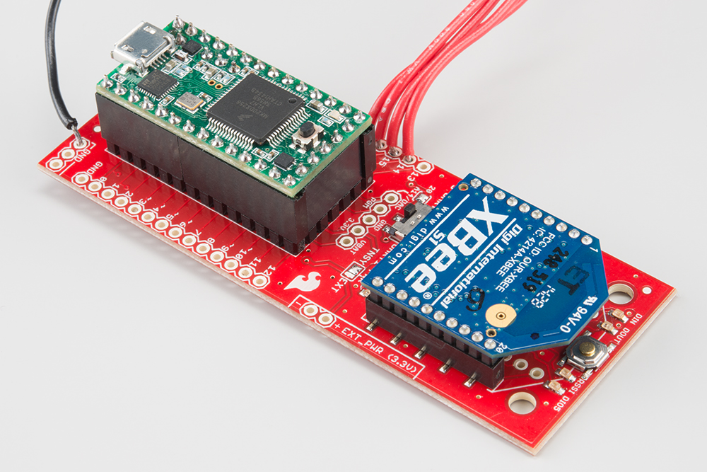

Sparkfun xbee explorer regulated

